**ML Assignment**

**Name: Danhong Tang**

**Student Number: 200471292**

**Task 1: Week 1: HDFS**

Part 1

=============

Create a test file which is more than 500 MB then upload it then run the command mentioned in the lecture (Slide 92 -97)

In putty, Enter the IP address and username and password,

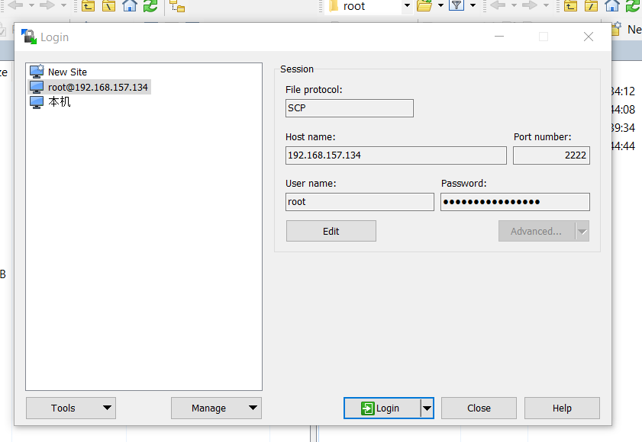

then pull testData.rar into test folder.

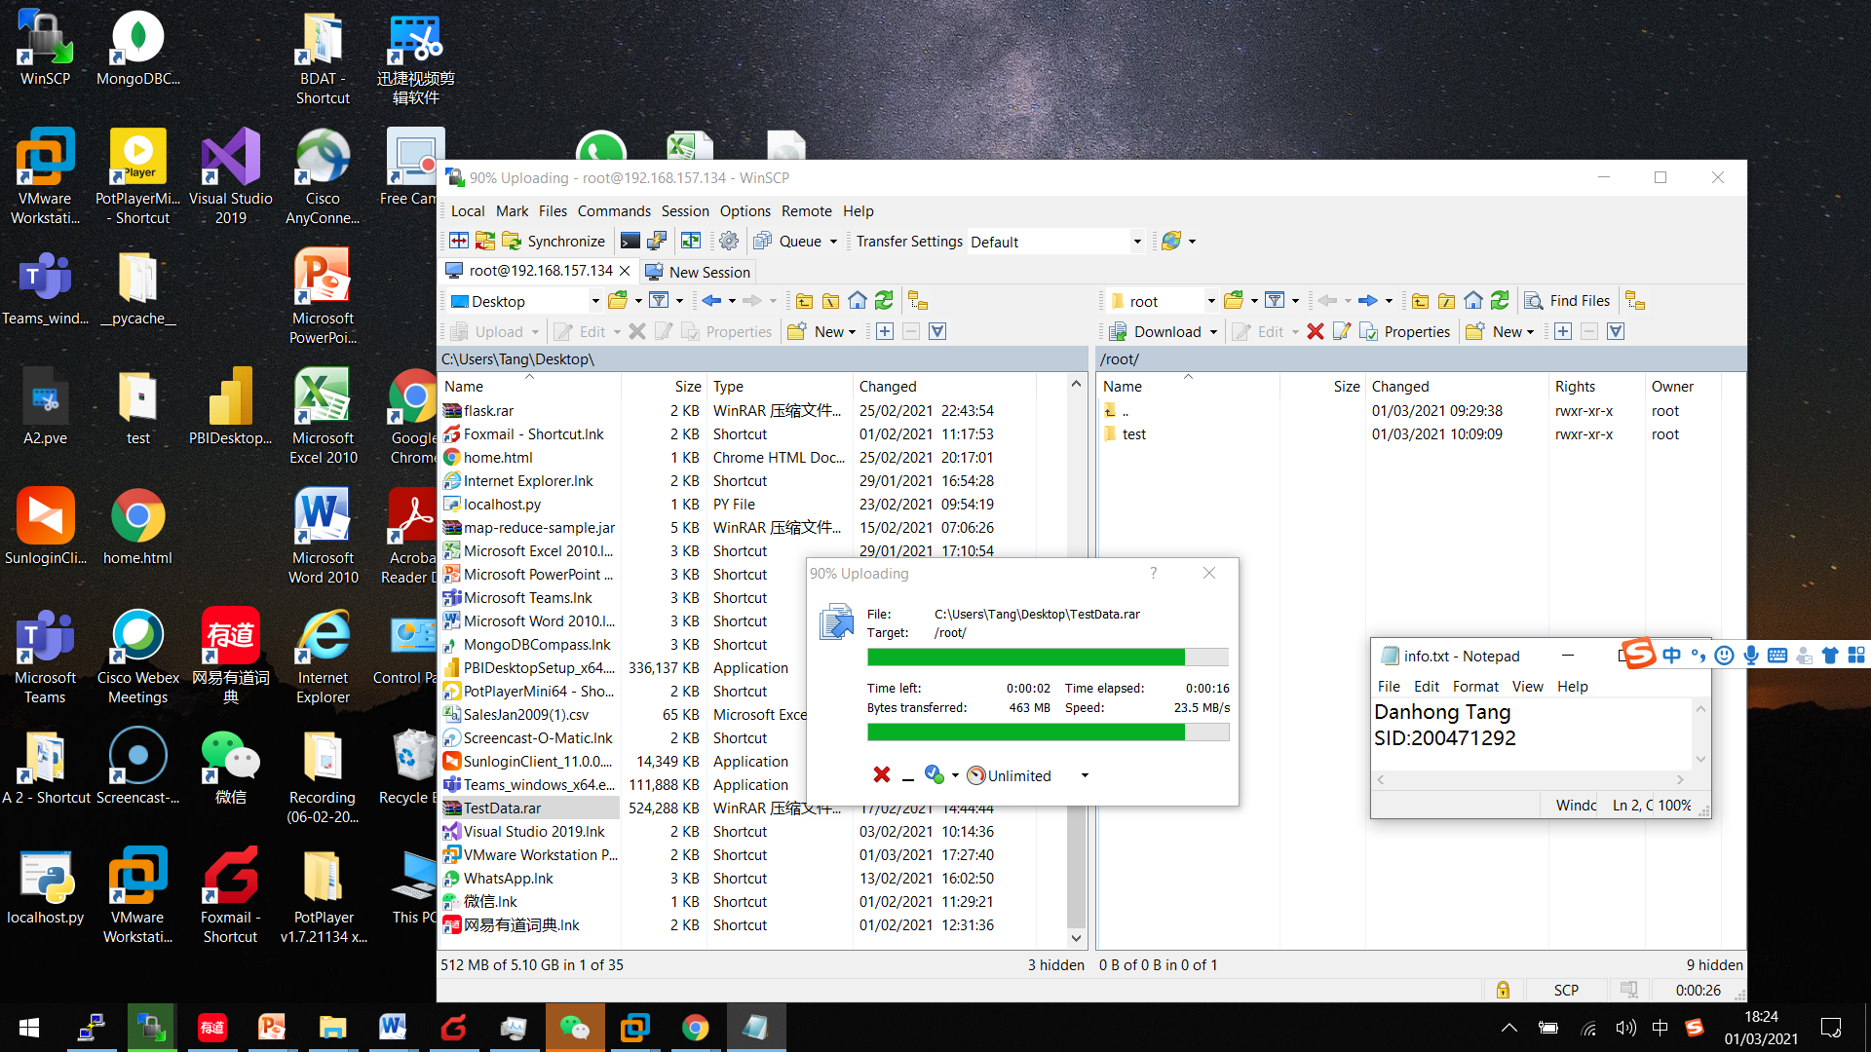

Using ls we can see the testData file existing

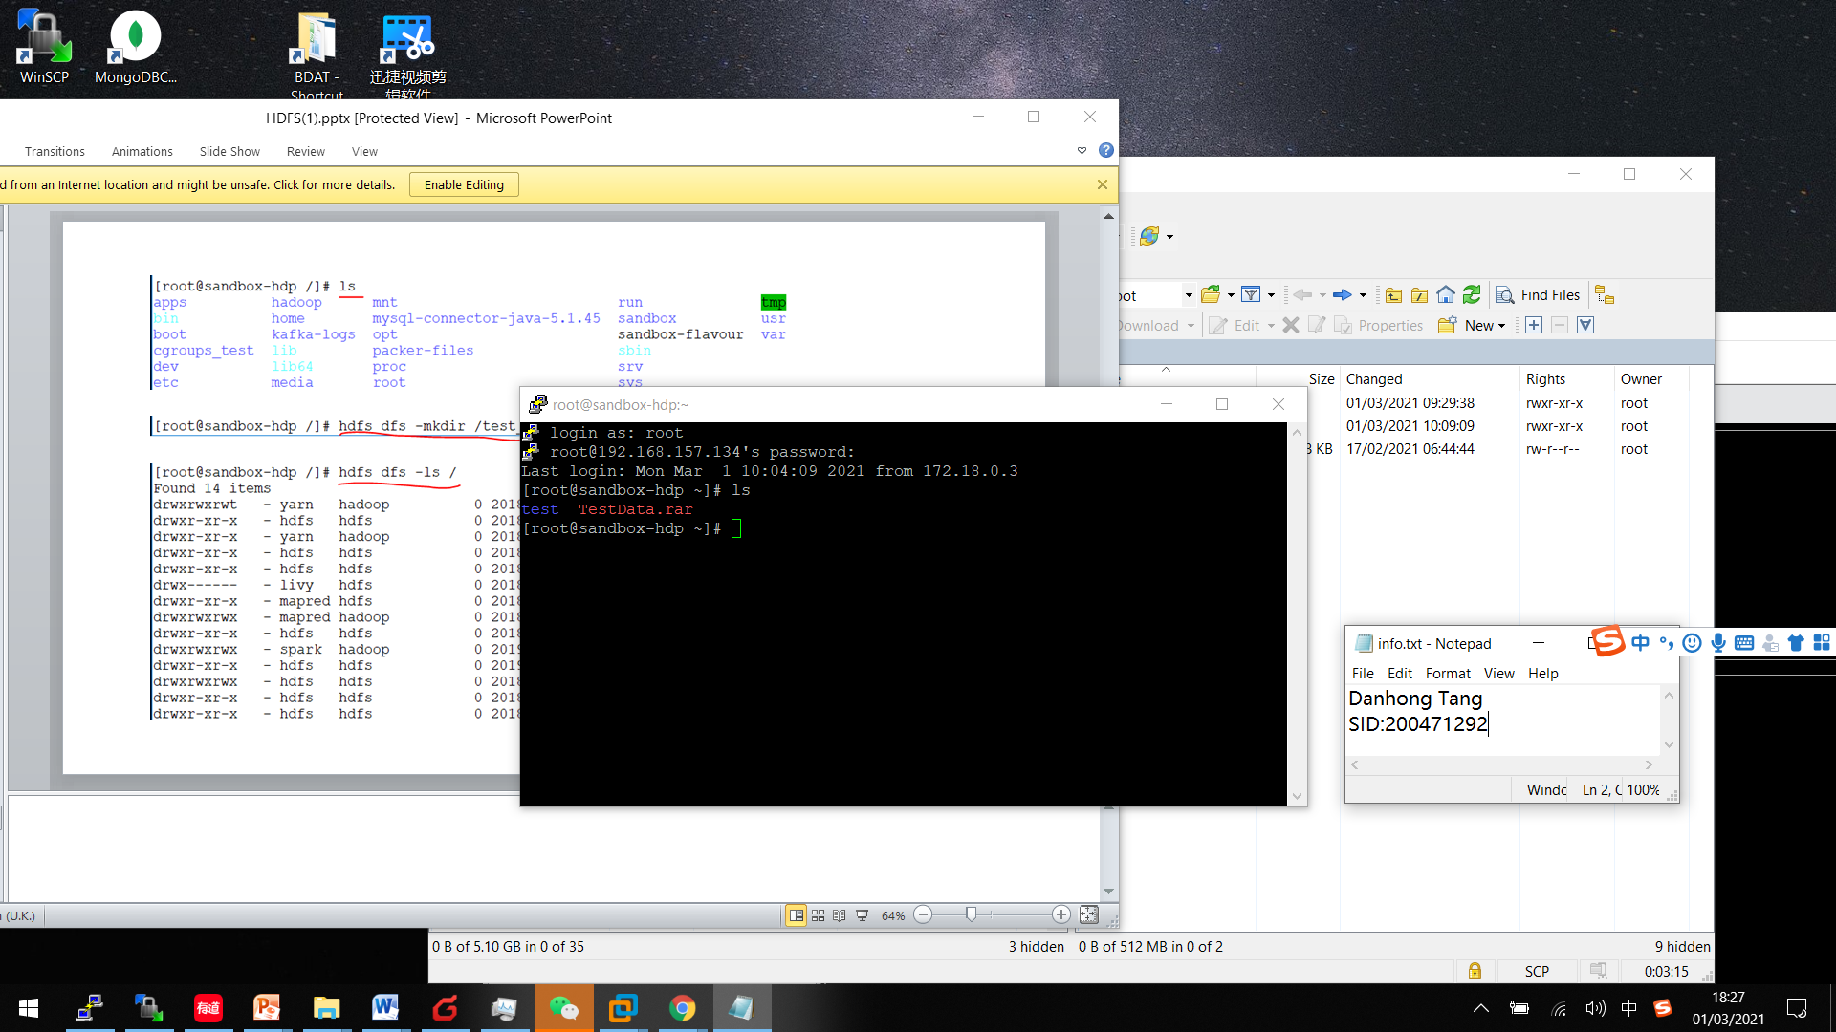

Created a directory testData and found it in HDP :

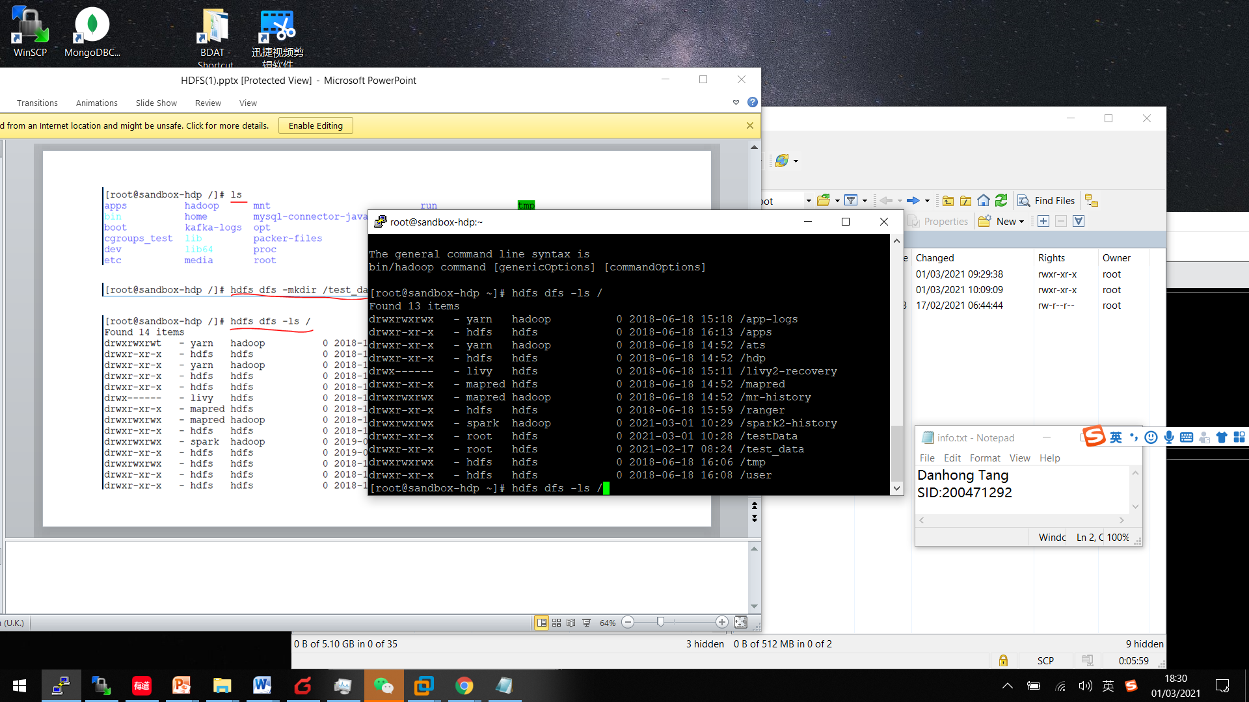

Chang name from “root” to “hdfs”

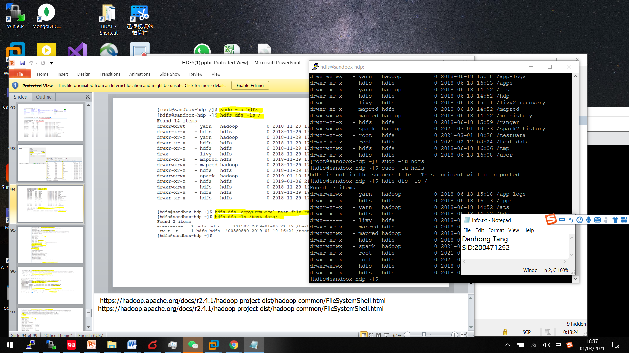

Move file from local to hdfs and check healthy status of the file :

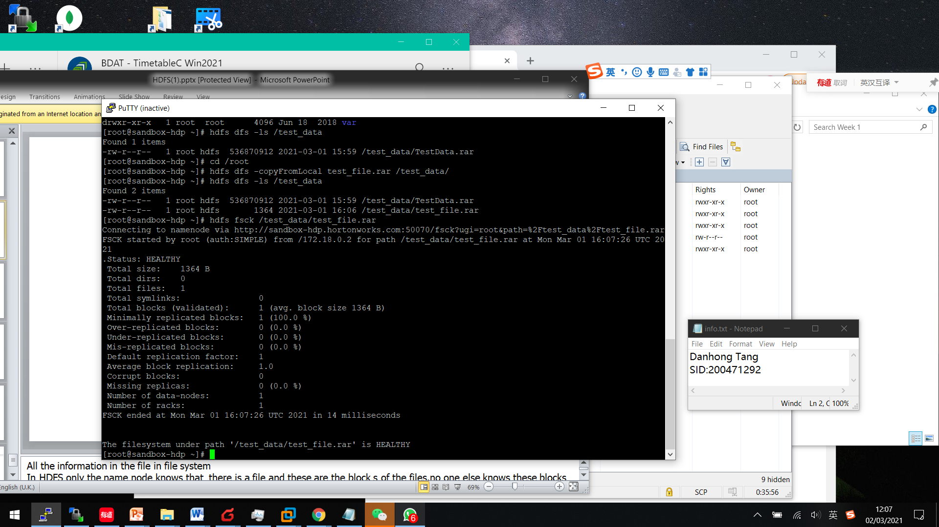

Removed test_file and check it was not in the test_data again :

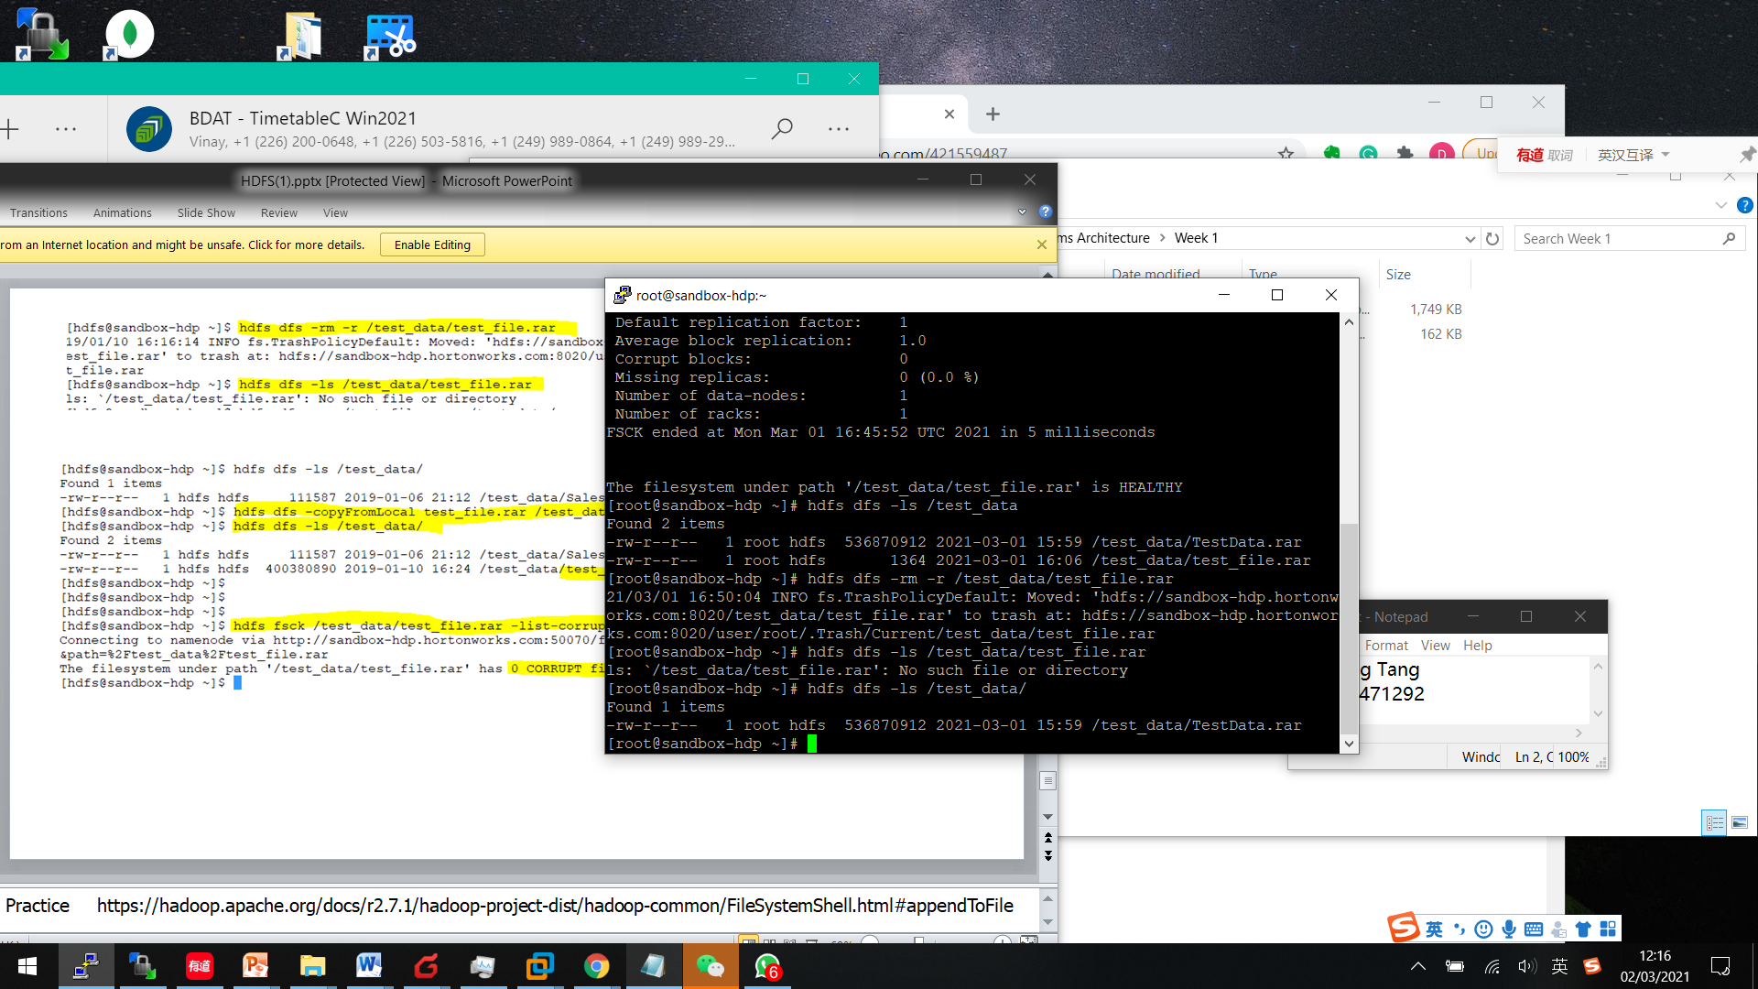

Copied test_file.rar back to test_data:

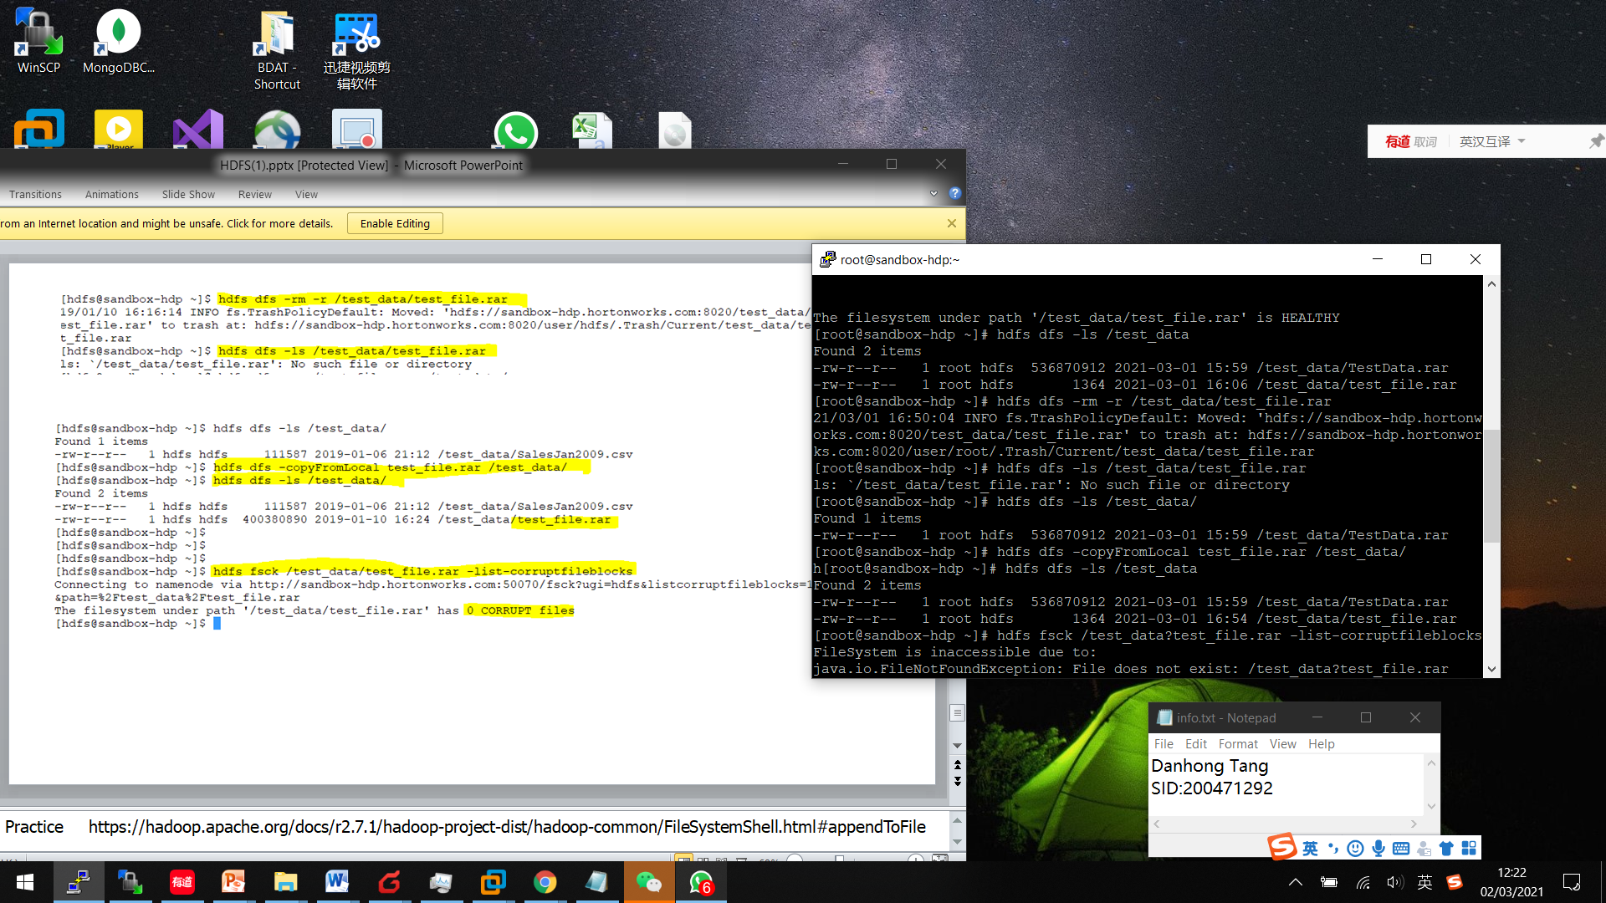

To see corrupting fileblocks :

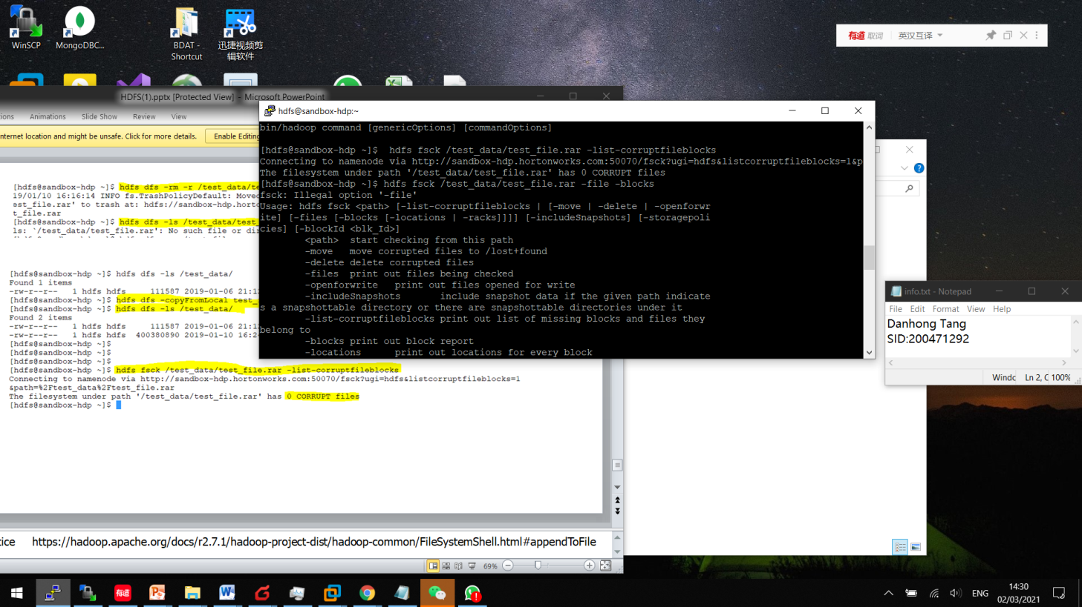

To see which block the file is in :

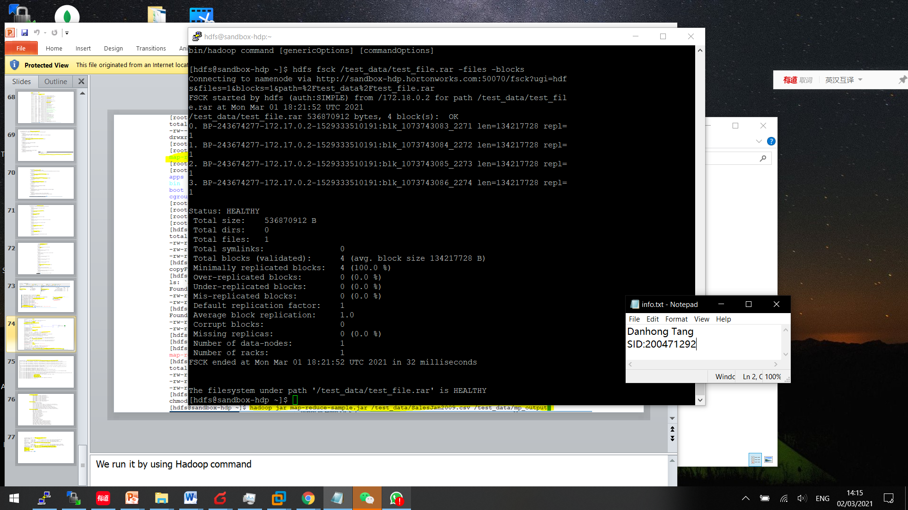

Part 2

======

use the following LINK and explore the commands for fsck and dfs .5 commands from fsck and 5 commands from dfs

.https://hadoop.apache.org/docs/r2.6.0/hadoop-project-dist/hadoop-hdfs/HDFSCommands.html

* Add file and remove :

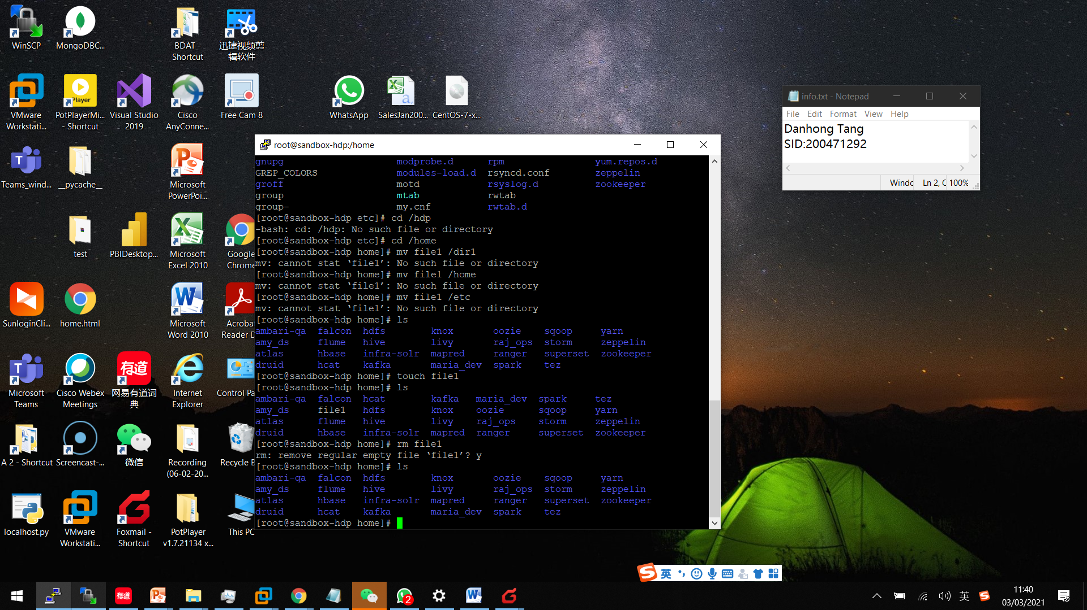

Copy file1 to etc :

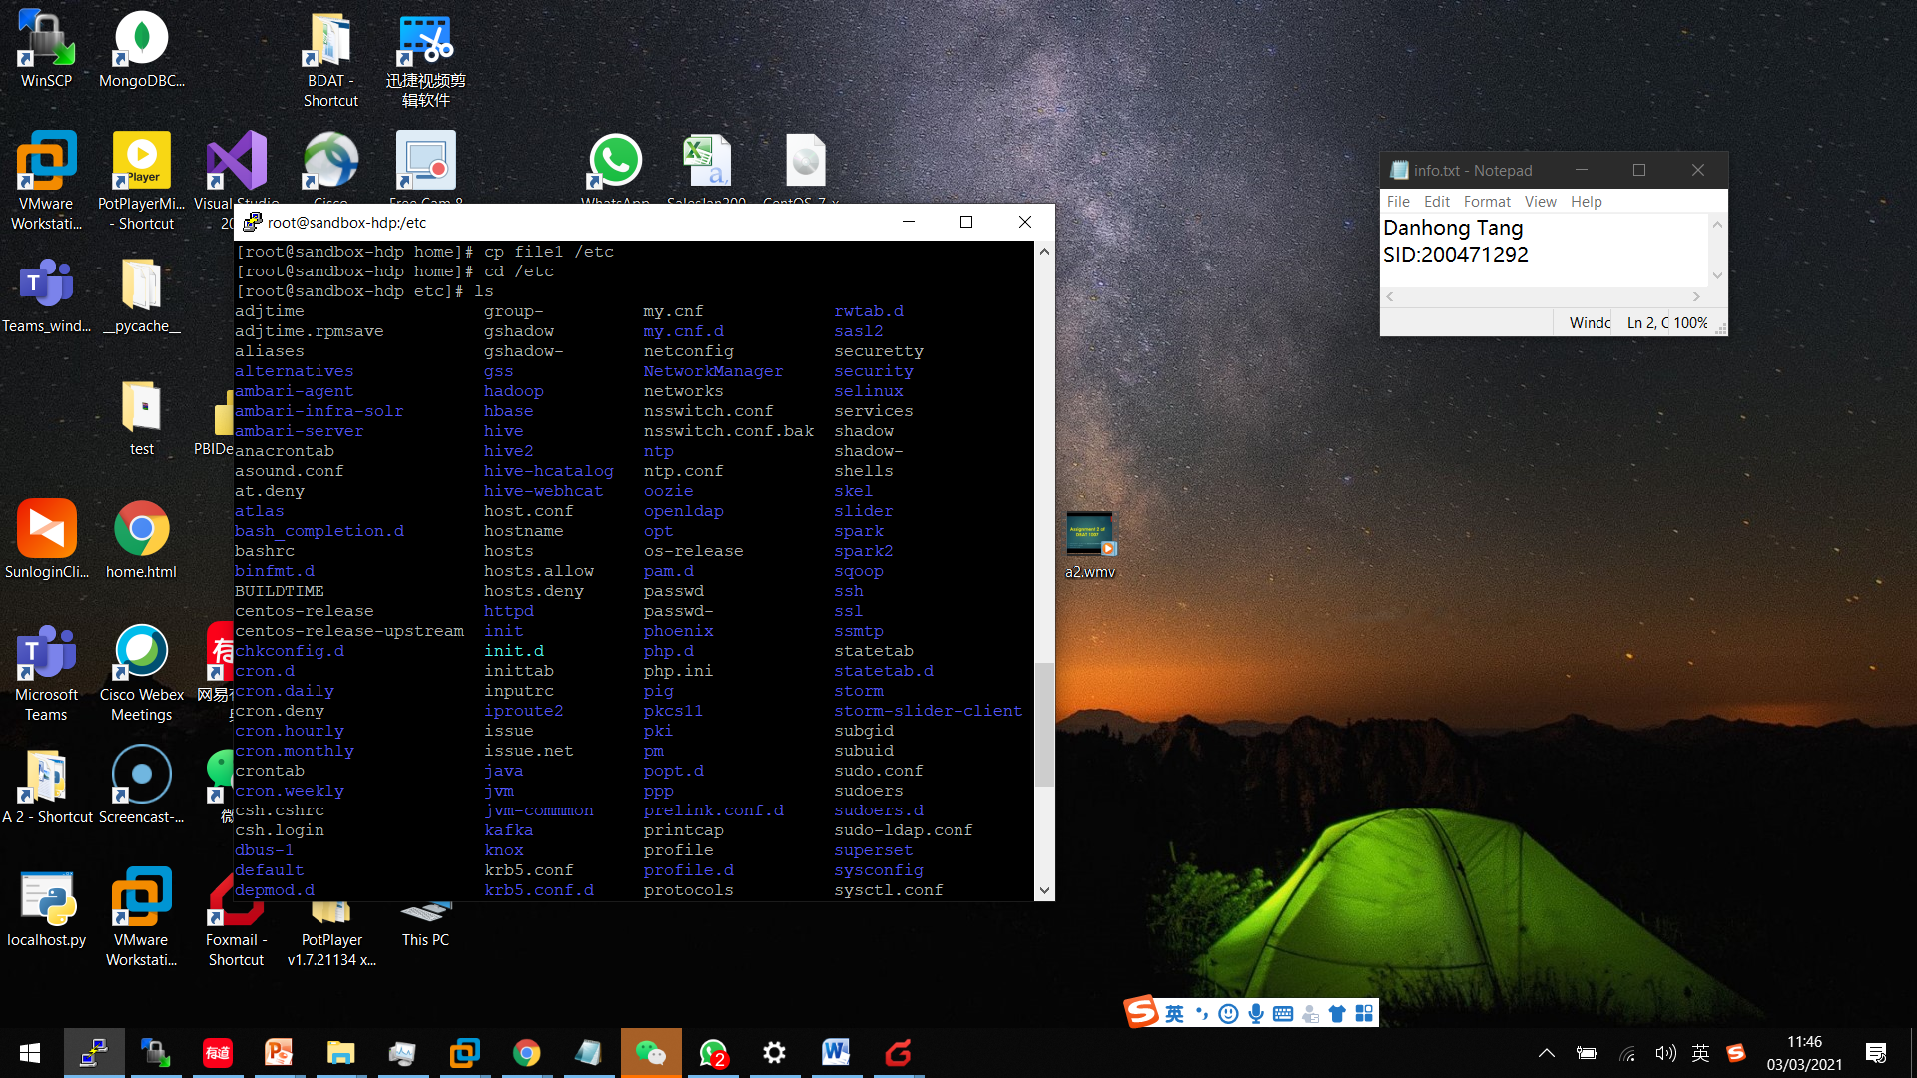

* Check file size and use Vi editor:

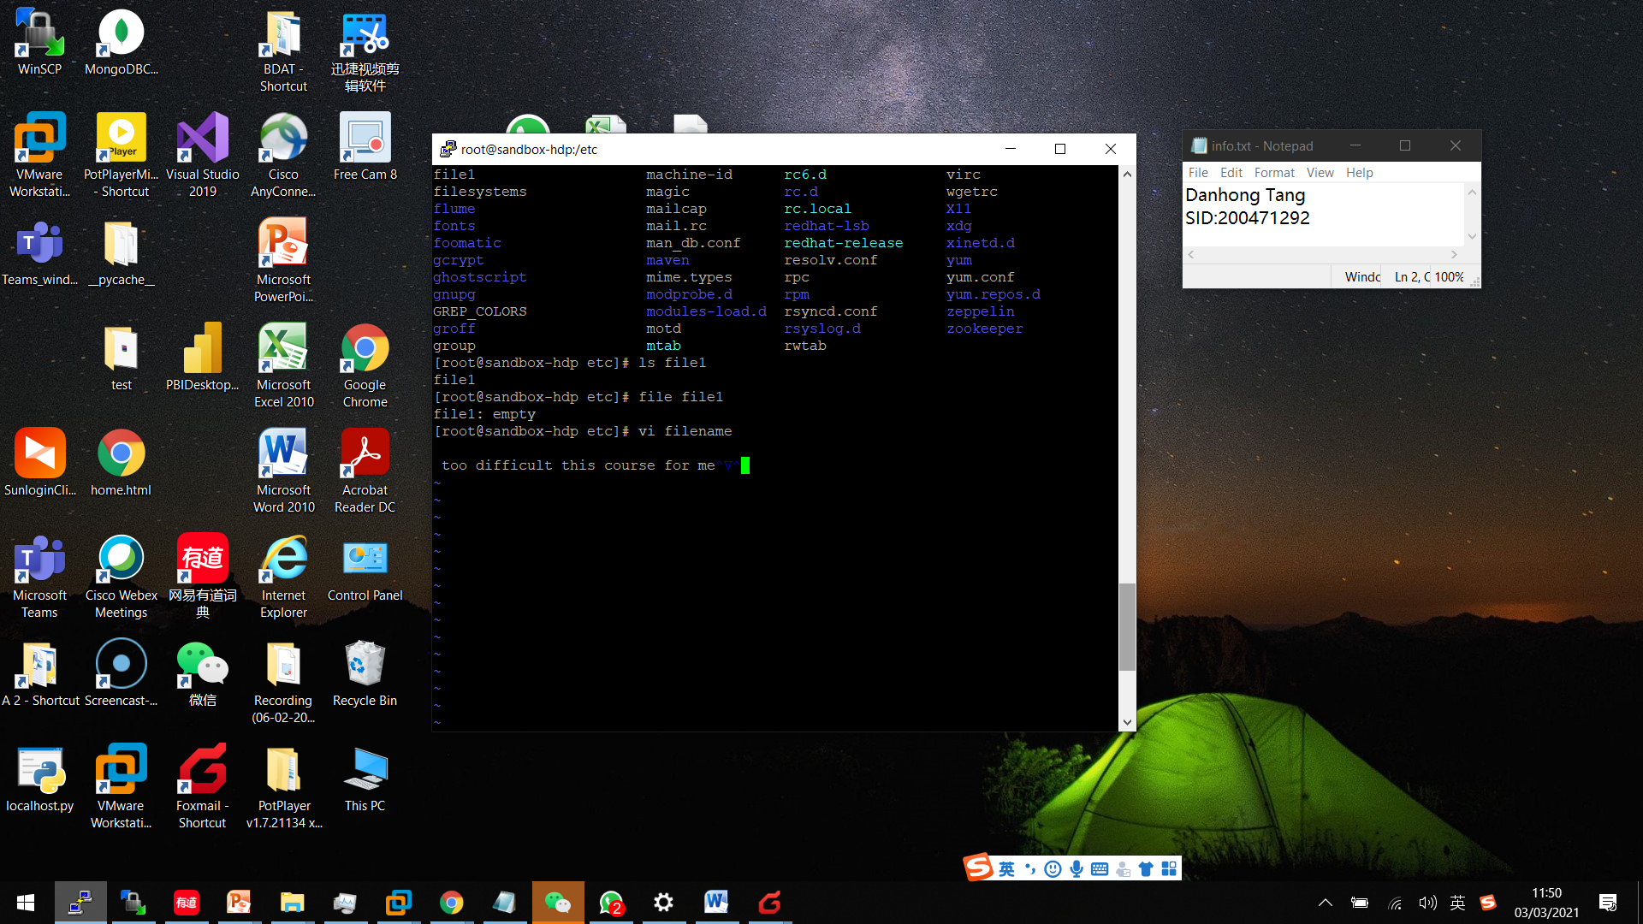

* Whoami, uptime, ps,top

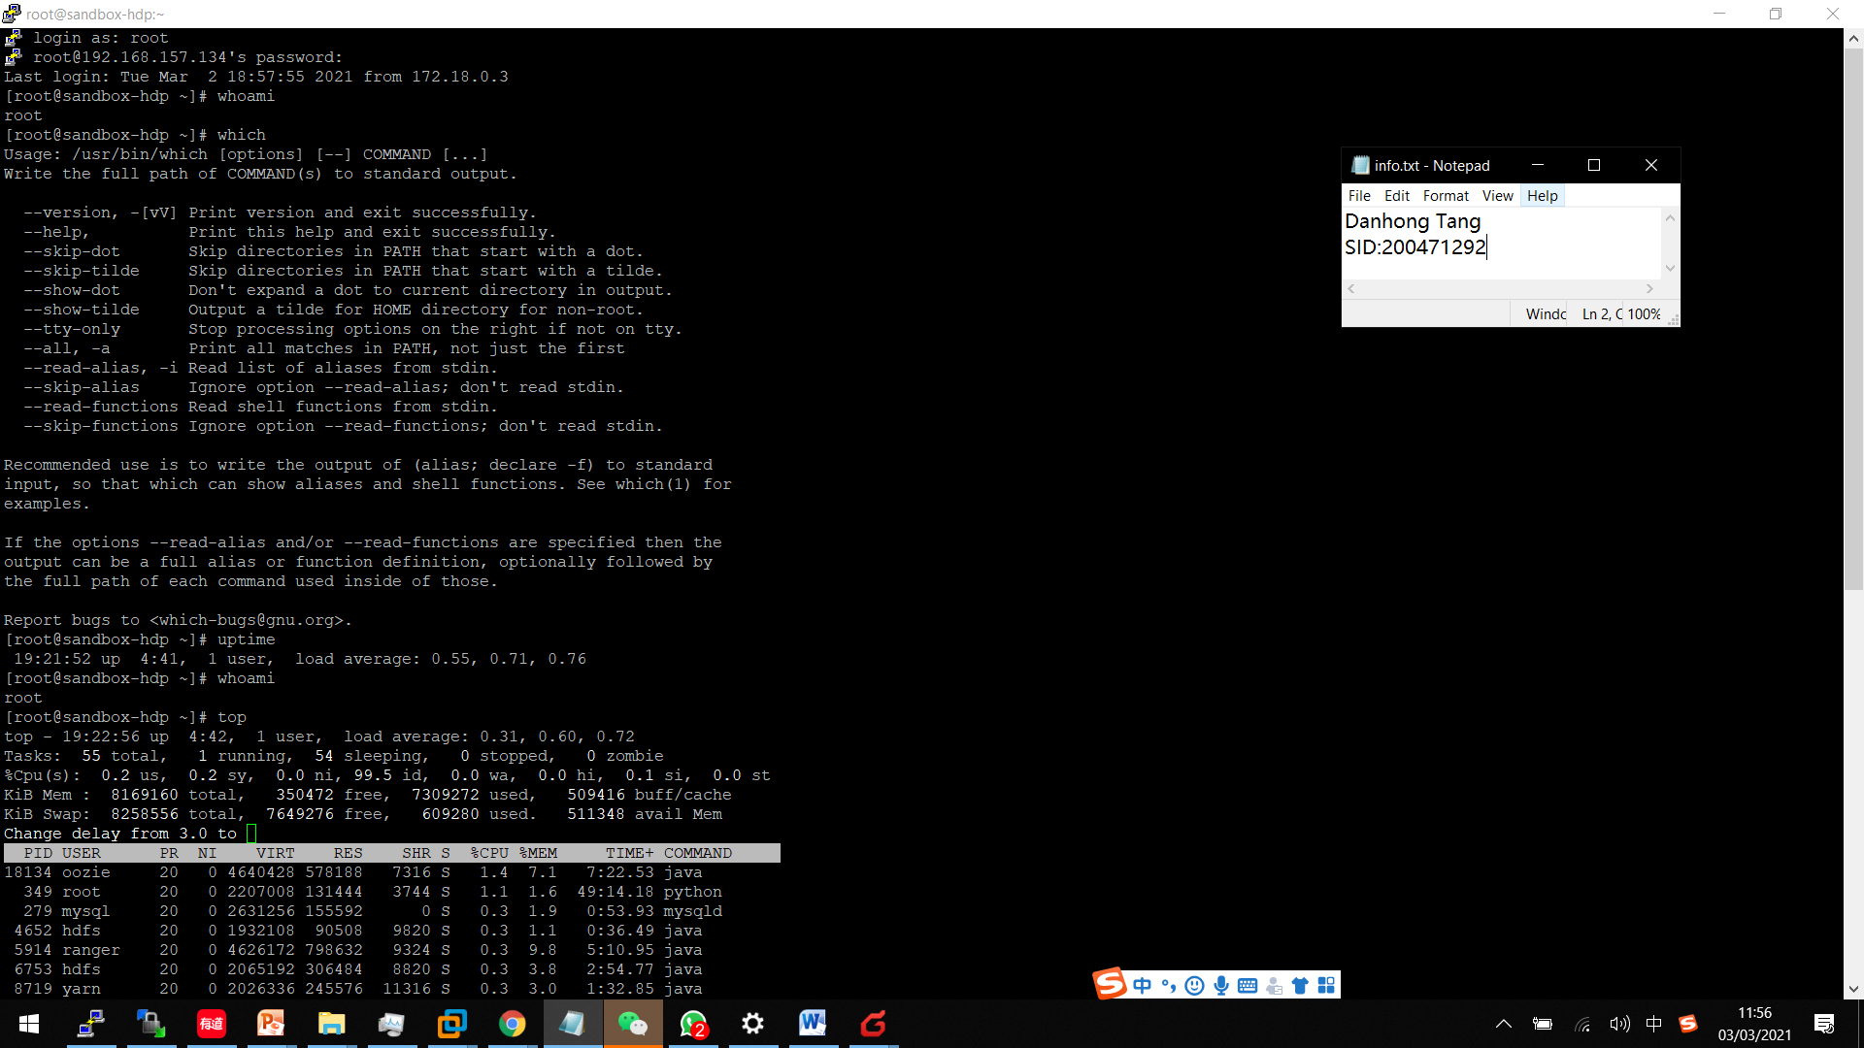

* Cat

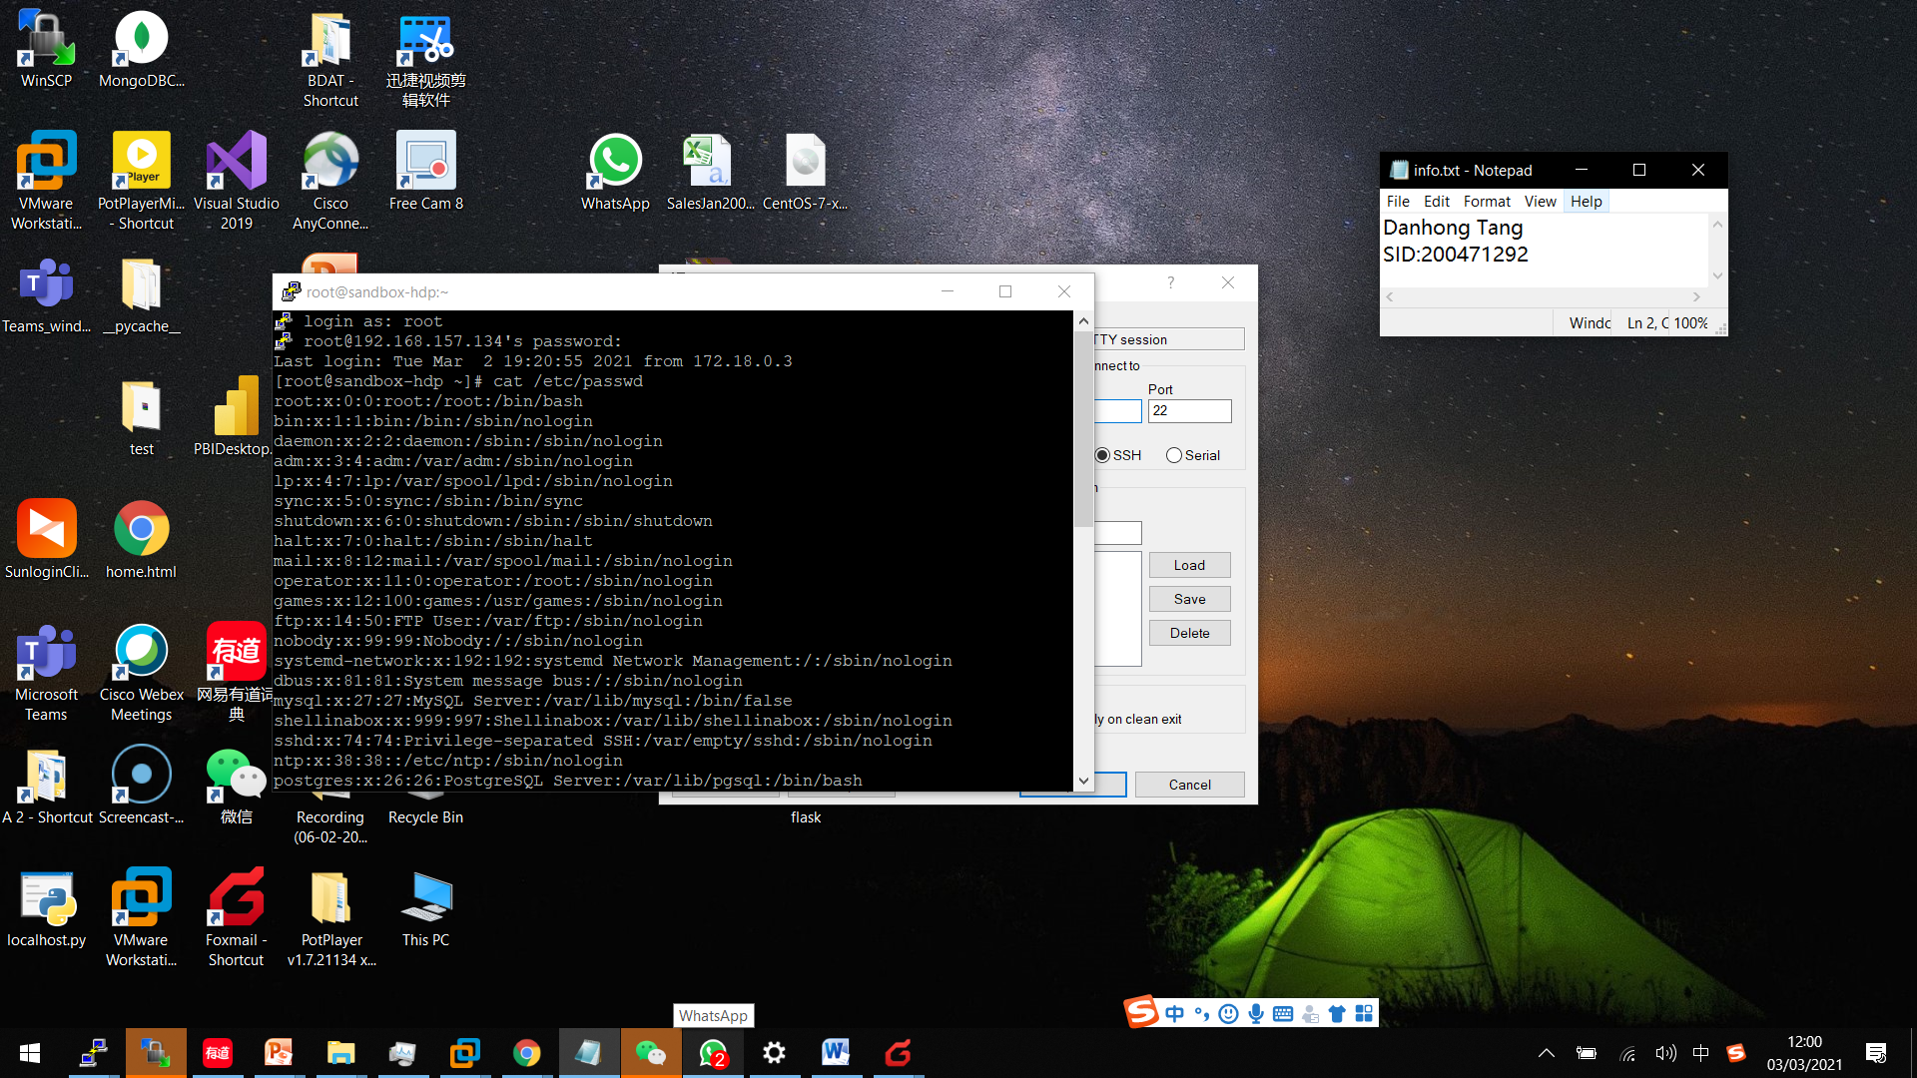

**Task 2 :** **Week 2 : Map Reduce Lecture**

**Do Slides 75-77**

P75：Processed a task with map-reduce-sample.jar and put the result in test_data with the name mp_output:

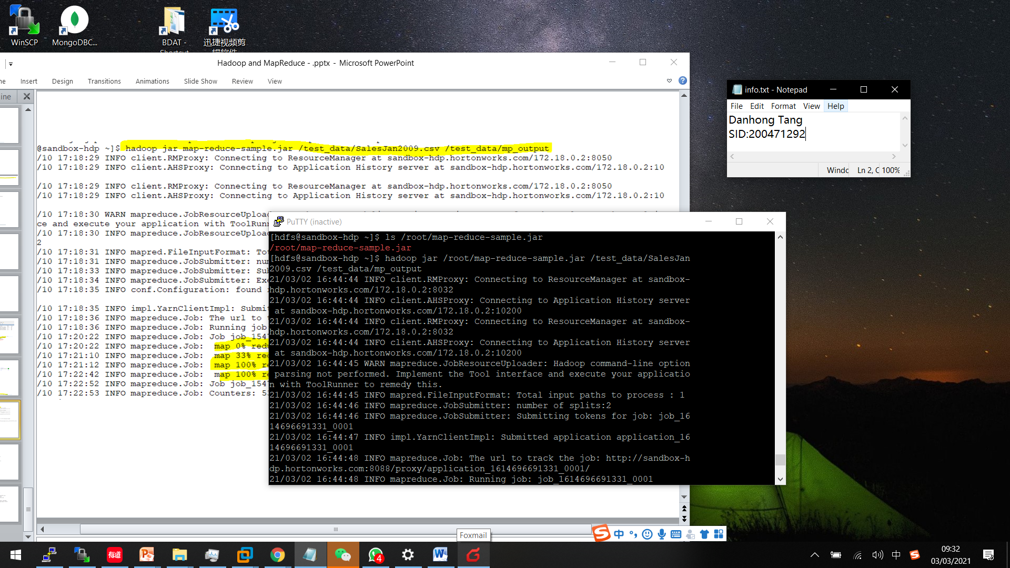

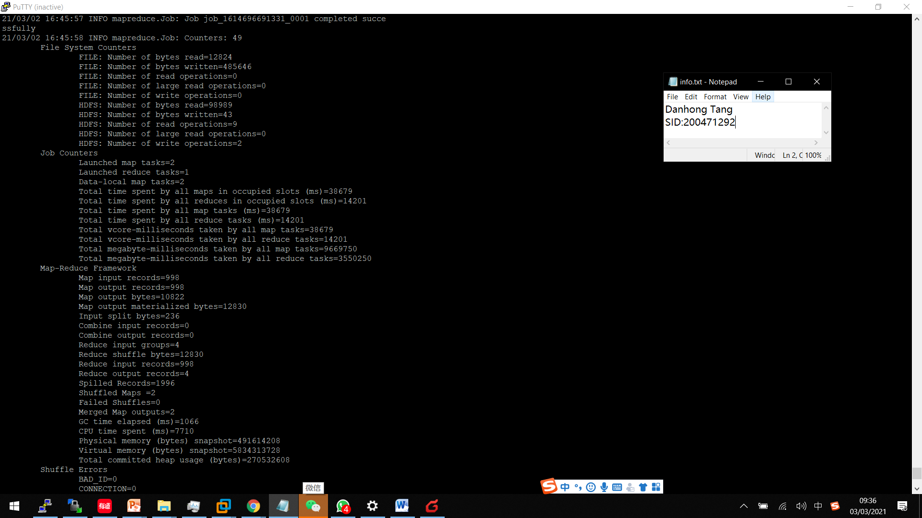

**Check test_data and mp_output, there are files and results there :**